

**Medical Directors Forum**

Spring 2023

**Detailed Notes**

**(Clinician Version)**

**Primary Care Almanac**

**Introduction:**

Partnership HealthPlan of California’s (Partnership’s) mission is:

**“To help our members, and the communities we serve, be healthy.”**

This dual focus – on both the individuals who are members of the health plan and the communities that we all live in – is rooted in our not-for-profit status and our governance structure. Our governing Board of Commissioners includes a diversity of representatives from all 14 counties that we serve in Northern California.

Partnership’s vision is:

**“To be the most highly regarded health plan in California.”**

We strive to be highly regarded by our members, the provider network comprising our health care delivery system, our community partners, the state legislative and executive branches, other health plans (our peers), and by our employees. This requires engagement and communication with each of these groups. The Medical Directors Forum is one example of this.

**Facilitator/Presenter**

Robert L. Moore, MD, MPH, MBA, FAAFP

Chief Medical Officer

**E-Mail:** [rmoore@partnershiphp.org](mailto:rmoore@partnershiphp.org)

**Your Regional Medical Directors:**

[Marshall Kubota](mailto:mkubota@partnershiphp.org), MD, Regional Medical Director (Marin, Sonoma, Mendocino and Lake Counties)

[Colleen Townsend,](mailto:ctownsend@partnershiphp.org) MD, Regional Medical Director (Napa, Solano and Yolo Counties)

[Jeff Ribordy](mailto:jribordy@partnershiphp.org), MD, Regional Medical Director (Humboldt, Del Norte, Trinity, Shasta, Siskiyou, Modoc and Lassen Counties)

Partnership website:  [www.partnershiphp.org](http://www.partnershiphp.org/)

Table of Contents

Clinicians needed to serve on Partnership Advisory Committees. 6

County Profiles 6

Partnership Strategic Issues 7

Geographic Expansion 7

Medi-Cal Redetermination: what Clinicians Need to Know 8

CalAIM Update 9

Medi-Cal Rx: Pharmacy Carve-Out Reminders 11

Kaiser Statewide Contract 12

Implementation of New Core Claims Processing System 13

State Policy Updates 13

California Budget for 2023-24: Governor’s January Budget 13

Bills to watch in Sacramento 14

Some bills of note that passed in 2022 14

Some bills of note introduced in 2023 14

Potential Ballot Initiatives for 2024 15

Other Partnership Legislative Priorities 15

Rural Health Policy Priorities 15

Supporting Hospital Maternity Services in the PHC Region 16

California POLST Registry Status Update 18

Federal Policy Update 19

Draft Rules in Process 19

Recent Laws Passed 19

Anticipated Congressional Activities 20

Partnership COVID-19 Updates 20

Covid-19 Therapeutics Available 20

Covid Home Test Kits Covered for Medi-Cal Beneficiaries through May, 2024 20

COVID-19 Vaccines 20

Partnership Benefit and Program Updates 21

Reminder of benefits and service that began in prior years. 21

Blood Pressure Devices and Cuffs through Community Pharmacies 21

Coverage for Community Health Workers 22

Coverage for Doulas 23

Coverage for Dyadic Services 23

Street Medicine 24

Behavioral Health Updates 24

Beacon Health Options is now Carelon Behavioral Health 24

Patients on MAT Plus Opioids: Prescriber Letters 24

Removal of Federal X-Waiver Requirement 25

Partnership’s Wellness and Recovery Program Update 26

Members with High Complexity Eating Disorders 26

Hints for Getting an Appointment with a Carelon Provider 26

Supporting Behavioral Health Needs in Children: UCSF’s Child & Adolescent Psychiatry Portal 27

Obtaining Psychological and Neuropsychological Testing 27

Bright Heart Health: On-Demand Behavioral Health 27

Public Health Updates 28

Lead Screening Update 28

Vaccination Rates in Pregnancy: 30

Clinical Updates 31

USPSTF Major Updates 31

Hepatitis B Vaccine Now Recommended for All Adults 31

Updated Recommendations for Pneumococcal Vaccinations in Adults 32

New Requirement to Submit Immunization Data to a California Registry 33

Cognitive Health Assessments Required Annually for Patients over age 65 33

Pediatric Well-Child Care Screening Tools 33

Screening Tool Highlights 34

Coding For Pediatric Screening 35

Understanding PHC Requirements for Glucose Monitors and Insulin Pump therapy for Diabetes 35

Part I: Glucose Monitoring: When is Continuous Glucose Monitors Indicated? 35

Part II: Continuous Insulin Infusion 37

What PHC is Looking for in TAR Requests for CGMs and Insulin Pumps 38

Foot Care for Patients with Diabetes: Using Partnership Benefits to Decrease Amputations and Ulcerations 38

Treatment Resistant Urethritis or Cervicitis? Consider Possibility of *Mycobacterium genitalium* 39

Clinical Practice Guidelines for Primary Care 40

Health Services Updates 40

Transportation Benefit Changes for PHC Members 40

Genetic Testing 40

Options for Accessing Diabetes Education and Nutrition Counseling for Your Patients with Diabetes 41

Care Coordination Services at Partnership 42

The Intensive Outpatient Palliative Care Benefit 43

CMO Updates 44

Providing the Highest Quality of Care with a Shortening Half-Life of Medical Knowledge 44

Shortage of Primary Care Clinicians: Potential Solutions 44

Collaborating to Achieve System Wide Changes 44

Looking for Opportunities to Improve 45

Health Equity: What it Means for Primary Care 45

Knowledge Management: Don’t Reinvent the Wheel 45

The Hazards of Medical Spanglish 45

Series on Diagnostic Accuracy 45

Wake up your Mirror Neurons 46

Customizing your Electronic Health Record for Quality 46

Clinical Quality Measure Inequities 46

Inequities based on 2021 HEDIS measurement year 46

Inequities based on PCP QIP data 47

Quality Improvement Updates 49

DHCS Quality Measure Changes 49

Electronic Clinical Data Systems (ECDS) Measures 50

PCP Patient Experience Results for 2022 52

Hospital OB Measures, 2021 54

Pay for Performance Program for Primary Care (PCP QIP) 55

PCP QIP Measures for 2023 55

Discount opportunity for practices applying for *initial* PCMH NCQA recognition 57

Calendar for Focusing on Measures 59

Specific Support for Priority Quality Measures 59

Flu vaccination key to improving CIS-10 vaccination rates! 59

Testing for Streptococcal Pharyngitis 60

COPD Exacerbation Management 60

Statin Therapy Lagging in Patients with Cardiovascular Disease or Diabetes 61

A Quick Guide to Starting Your Quality Improvement Projects 62

Other Quality Updates 63

Health Equity/Practice Transformation Grant Program 63

Partnership Quality Dashboard 63

Developmental Screening 65

Audit Shows Many Child-Health Providers Misuse of Developmental Screening Code 66

ACEs Screening 66

Upcoming Educational Events 68

Partnership Sponsored Events 68

Equity in Health Care 68

ABCs of Quality Improvement 68

Webinars on Topics Related to Substance Use Disorder 69

Accelerated Learning Education Program: Early Cancer Detection (Cervical, Breast, and Colorectal Cancer Screening) 70

Quality & Performance Improvement Training Events 70

Improving Access through Office Efficiency 70

Mandatory Cultural Competency Training 71

Recommended Educational Opportunities Outside of Partnership 71

Advancing Health Equity: Linking Quality and Equity in QI Projects 71

Grow Your Own Workforce: Best Practices to Train the Next Generation 71

Annual Palliative Care Summit 72

Rural Health Innovation - Berkeley Public Health Online 72

Institute for Healthcare Communication - 21.25-Hour Faculty Development/Train-the-Trainer Course 72

# Partnership Strategic Issues

Medi-Cal Redetermination: what Clinicians Need to Know

There has been a lot of publicity from DHCS and others about the end of the pause on removing Medi-Cal members who do not update their information at their usual re-determination time. The marketing to patients has sometimes been hard to understand, causing stress to patients. Here is an alternative way to understand what is happening.

Each year, around the anniversary month of each Medi-Cal beneficiary’s last enrollment into Medi-Cal, all current Medi-Cal beneficiaries are mailed to their official address a packet of information to complete (redetermination). Before COVID, individuals who did not complete this paperwork were typically dis-enrolled from the Medi-Cal program, until they completed the paperwork requested, through their local county. During the COVID pandemic, beneficiaries continued to be covered by Medi-Cal whether or not they completed the redetermination paperwork.

Starting in April, those who do not respond will have their eligibility discontinued. Many of those who are expected to not respond have died, moved out of state, or received commercial insurance, and so discontinuing their Medi-Cal would be appropriate.

Others who have moved to new addresses, but who have not updated their address with DHCS or their County eligibility work will not receive the redetermination notice, and not know they have lost Medi-Cal until they try to use their benefit for something (like come in to the office or pick up a medication). This is why DHCS is urging everyone who has moved since 2019 to log in and update their address and other contact information, so their re-enrollment packet will be sent to the correct address on the anniversary of re-enrollment.

Even if the redetermination notice is sent to the correct address, about 10% of the Medi-Cal population fails to submit the paperwork right away (competing priorities), or send in an incomplete packet. For these individuals, the state message is, “Keep an eye out for the redetermination packet when you receive it around the time of year of your last enrollment.”

To mitigate the number of individuals who lose eligibility, DHCS will use redetermination for other related programs (such as SNAP) to auto-renew some individuals in Medi-Cal. Another tactic is to continue the pause on redeterminations for beneficiaries from age 26-50 until after 2024, with the idea that they may qualify for Medi-Cal in 2024 under the expansion of Medi-Cal to currently uncovered populations; DHCS wants to avoid them falling off insurance just before they qualify again. An estimated 700,000 individuals state-wide will be covered by this coverage expansion; at least 45,000 live in the 24 Partnership counties.

Current estimates are that at least 20% of current Medi-Cal enrollees will lose Medi-Cal every over the next year, for an average of 1.8% per month.

When patients arrive without Medi-Cal eligibility, they should be referred to the County Medi-Cal eligibility department. Knowing that they often will restore services somewhat retroactively, your health center or office may elect to care for patients’ immediate needs, while urging them to resolve the underlying incomplete paperwork process.

CalAIM Update

California Advancing and Innovating Medi-Cal (CalAIM) is a multi-year initiative by the DHCS to implement overarching policy changes across all Medi-Cal delivery systems with these objectives:

1. Reduce variation and complexity across the delivery system;
2. Identify and manage member risks and needs through population health management strategies
3. Improve quality outcomes and drive delivery system transformation through value-based initiatives, modernization of systems and payment reform.

Two components of CalAIM that began in January 2022 are Enhanced Care Management (ECM) and Community Supports (CS, formerly known as In Lieu of Services).

For documents and presentations related to the ECM and CS programs, see our website: <http://www.partnershiphp.org/Community/Pages/CalAIM.aspx>

The current categories proposed for populations covered by ECM and the potential services covered by ILOS are listed here:

ECM target populations:

The following populations are currently approved:

1. Adults and children at risk for institutionalization with serious mental illness (SMI), substance use disorder (SUD) with co-occurring chronic health conditions, or children with serious emotional disturbance (SED),
2. Individuals experiencing homelessness, chronic homelessness or who are at risk of becoming homeless.
3. High utilizers with frequent hospital admissions, short-term skilled nursing facility stays, or emergency room visits.
   1. Children or youth with complex physical, behavioral, developmental, and oral health needs (e.g. California Children Services, foster care, youth with clinical high-risk syndrome or first episode of psychosis).
   2. Individuals at risk for institutionalization who are eligible for long-term care services.
   3. Nursing facility residents who want to transition to the community.

In January 2024, one last population will be added.

* 1. Individuals transitioning from incarceration who have significant complex physical or behavioral health needs requiring immediate transition of services to the community. (Note: many individuals in this population may qualify sooner if they have one of the above other conditions.)

Community Support Services covered by Partnership include the following:

* + - * Housing Transition Navigation Services
      * Housing Deposits
      * Housing Tenancy and Sustaining Services
      * Short-term Post-Hospitalization Housing
      * Recuperative Care (Medical Respite)
      * Respite Services
      * Meals/Medically Tailored Meals
      * Personal Care and Homemaker Services

As of March 27, Partnership had fully executed contracts with 59 Enhanced Care Management providers and 45 Community Support Services providers, covering all 14 counties. Current enrollment in Enhanced Care Management is 1690 members; a total of 2600 members have ever been enrolled. A total of 1741 members have received at least one Community Support service.

If you wish to refer a patient for consideration for ECM or CS services, have your care coordinator contact our Care Coordination team by securely emailing us at: [CareCoordination@partnershiphp.org](mailto:CareCoordination@partnershiphp.org) for our Southern counties, or [CCHelpDeskREDDING@partnershiphp.org](mailto:CCHelpDeskREDDING@partnershiphp.org) for our Northern counties.

Medi-Cal Rx: Pharmacy Carve-Out Reminders

The state pharmacy carve-out, known as Medi-CalRx went live in January 2022. After more than a year of transition activities, the last phases of the implementation (removing the “grandfathering” of medications approved for the first year) came to an end in March 2023.

Reminders for optimal use of Medi-CalRx:

Bookmark the hyperlink <https://medi-calrx.dhcs.ca.gov/home/cdl/> to access the Contract Drug List to see what preferred drug is covered.

Be sure any new clinicians who join your practice sign up for CoverMyMed and have access to the TAR processing system set up by Magellan/DHCS, to allow them to submit TARS more expeditiously. The primary methods for TAR submission is fax, the Magellan Provider Portal, and CoverMyMed (CMM), a commercial online platform for drug prior authorization. Most prescribers and pharmacies are using CMM as the platform for completing TARs. However, pharmacies can only initiate the TAR on CMM and are blocked from submitting the TAR to Medi-Cal. Under Medi-Cal Rx, only the prescriber can submit the TAR to Medi-Cal through CMM. If you receive a notification from CMM or the pharmacy to complete a TAR, please complete the TAR on CMM and submit to Medi-Cal. You can also print out the form and fax the TAR directly to Medi-Cal at 800-869-4325.

Magellan is responsible for fielding calls from both members and providers for problems they encounter. If you or your patients find this system is not working in individual cases, please contact Partnership to assist. Resolution through Magellan should always be pursued first. Here are some options:

1. If you as a prescriber want to have a conversation with Magellan about a TAR deferral to discuss the particulars of the case. Please call Magellan at 800-977-2273. This is especially important for urgent patient needs.
2. If an inappropriate denial of a medication is made, but it is not urgent, the standard process for appealing a denied TAR is to submit an appeal for the TAR adjudication results, clearly identified as appeals to: Medi-Cal CSC, Provider Claims Appeals Unit P.O. Box 610. Rancho Cordova, CA 95741-0610. Medi-Cal Rx will acknowledge each submitted TAR appeal within three days of receipt and make a decision within 60 days of receipt.
3. For patients who want to file a grievance related to the process, recommend that they call the Magellan customer support at 800-977-2273.
4. If these options are not yielding results, you can reach out to our Partnership pharmacy staff directly at 707-863-4155 to assist with getting Magellan to respond. Partnership does not have the ability to overturn Magellan/DHCS denials, but we have one additional escalation pathway we can use if the above are not successful.

# State Policy Updates

## Bills to watch in Sacramento

### Some bills of note that passed in 2022

AB 32 (2022) Aguilar-Curry. Guarantees that all visits via telehealth, including audio-only visits are paid in parity with in-person visits.

AB 1156 (2022) Weber, Akilah. Restores the ability for resident physicians who have completed one year of residency to have an unrestricted medical license to allow moonlighting and other activities.

### Some bills of note introduced in 2023

AB 85 (2023) Weber. Would require that PCPs are reimbursed for conducting screenings for social determinants of health. Would expand the coverage for community health workers. Would establish a working group to make recommendations to make better policy on screening and follow up for screening for social determinants of health. Priority bill for CAFP.

SB 598 (2023) Skinner. Establishment of a Gold Card for prior authorizations for physicians with a track record of previous approvals. Priority bill for CMA.

AB 1029 (2023) Pellerin. Would add a section to the official version of the California State Advanced directive form, allowing the option of a separate decision maker for mental health care decisions. Several palliative care physicians have expressed concerns; CCCC working with authors.

SB 424 (2023) Durazo. Would make a number of changes to the CCS program, including freezing participation in DHCS’s Whole Child Model to existing counties. This would affect the 10 Partnership Expansion counties, denying them the option of participating in the Whole Child model. Partnership and other local health plans of California are concerned about this last provision.

### Potential Ballot Initiatives for 2024

1. A tax on individuals earning over $5 million to support public health activities related to infectious disease control and pandemic prevention. (Public Health officers supportive)
2. Earmarking a Managed Care Tax to pay for raising Medi-Cal rates to the level of MediCare. (CMA, CPCA, LHPC all supportive)

### Other Partnership Legislative Priorities

* Promoting affordable broadband and wireless broadband throughout the PHC service area--both rural and urban.
* Same day billing for behavioral health and physical health visits (SB 282), Eggman and McGuire (2023)
* Addressing housing and homelessness.
* Promotion and support of behavioral health.

## Rural Health Policy Priorities

Interviewing physicians practicing in rural areas in the past year, some California **state** policy priorities especially important to supporting health care in rural areas were frequently mentioned:

1. Preserving (and improving) access to OB services to residents of rural areas
2. Improving the health status of Native Americans living in rural California.
3. Overhaul of the PPS system to better support FQHC rates given by DHCS.
4. Financial support for family medicine residencies and NP/PA residencies.
5. Increasing access to long-term care facilities in rural areas.
6. Promotion of broadband (wired and wireless) for rural areas.
7. Support of organized medicine in rural counties, to increase engagement, social support and professionalism of physicians practicing in rural settings.
8. Support of leadership training for clinicians and administrators practicing in rural settings.
9. Support for improving Medi-Cal rates to MediCare, across the board.
10. Support of activities to reduce the administrative burden of practicing medicine.

In particular, Partnership encourages every primary care provider to designate at least one physician in each county they offer services in to join the California Medical Society and their county medical society. The county medical society can then participate in promoting this rural health agenda through the CMA governance process.

## Supporting Hospital Maternity Services in the PHC Region

There has been a steady closure of maternity units in California over the last 28 years. Between 1995 and 2002, 28 hospitals closed maternity units in California, according to a study of the Petris Center at UC Berkeley. In the Partnership HealthPlan Service area, we have had seven hospital close their OB units in the past 7 years, with an 8th (Petaluma Valley) likely to close this year. Usually there are attempts for forestall closure for several years, with much community support.

Three of these OB units were in more rural areas, with a disproportionate effect on the vulnerable people living in these areas. A woman living in the mountains of Southern Humboldt, or the Mendocino coast, or Surprise Valley in Alturas, will have to travel 1.5 to 3 hours to a hospital with maternity services (longer if the weather is bad in the winter). Two studies that show that for each extra hour of distance to OB services, there is an incremental decline in outcomes. Maternal mortality rate association with longer distances is harder to show, given the relatively low rates of maternal mortality.

There is no single driver for these closures, but rather several confluent factors.

In rural areas, money was not the major issue, the non-monetary factors listed further below were the proximate causes. However, in the urban and sub-urban closures, **Medi-Cal rates** were an important contributing factor.

In the late 1980s, during the last major crisis of OB access, Medi-Cal dramatically increased rates for OB services and saw the access issues disappear within a couple of years. Unfortunately, like most Medi-Cal rates, there have been trivial increases in the rates from the 1990s to now. This effect is felt gradually by OB/GYNs, anesthesiologists, and hospitals. Combined with many other factors, the net result is that rational economic decisions lead practitioners to stop doing maternity services and hospitals closing down unprofitable OB units. With the Medi-Cal expansion, with a large proportion of hospitalized patients now with Medi-Cal, hospitals find it impossible to subsidize low Medi-Cal rates, by relying on MediCare and commercial contracts.

Over the years, a number of mitigating factors have made the low base rates of Medi-Cal less disruptive than they would have been. These include rising PPS rates for FQHCs, rural health centers, and rural tribal health centers; hospital directed payments; Medi-Cal Managed Care contracts with hospitals; Proposition 56 directed payments for office visits; hospitals subsidizing OB services based on favorable margins in other lines of business; the DHCS "kick-payment" methodology for paying health plans for deliveries.

In the end though, it may be time for another 1988-style readjustment in Medi-Cal rates for all specialists that contribute to OB services (including anesthesiology).

The **other major drivers** of decreased OB services in our service area are:

1. Challenges with staffing OB trained nurses in lower volume rural hospitals (there are number of sub-drivers of this).
2. COVID induced nursing shortages and a negative effect on hospitals reserves and budgets.
3. Challenges staffing pediatric coverage for potential unexpected complex births.
4. Overall trend of declining births in California.
5. Hospital chains with two hospitals in close proximity closing the lower volume OB unit to make the margins better at their adjacent hospital (allows the hospitals to respond to the 4 factors above plus the low Medi-Cal rates).
6. Medical Staff tendencies to resist transition from OB/GYN and Pediatrics to Family Physicians and Nurse Midwives, leading to less options when the economic or demographic factors kick in.

While no single policy change will re-open the units that have closed, we need to work together to address the underlying causes, to prevent further hospital OB unit closures, further affecting access to Medi-Cal beneficiaries.

Of note, the new doula benefit nor the dyadic services benefit do nothing to increase access to hospitals that can do these deliveries.

If we work together addressing multiple drivers, perhaps some closed OB units can be re-established in the more rural areas of the state.

Hospitals in the Partnership region that are at risk due to relatively low volume include both hospitals in Lake County, both hospitals in Siskiyou County, the one hospital in Del Norte County, the one hospital in Tehama County, and the one hospital in Lassen County.

(There are not hospitals currently doing OB services in Trinity and Modoc Counties in our current service area, nor in Plumas, Sierra, Colusa, Glenn counties in the additional 10 counties we will be expanding to in January 2024).

This is not on the priority list for the CMA, CPCA or CAFP. We need to have rural physicians and clinicians speaking up to raise awareness and working together to come up with solutions.

# Partnership COVID-19 Updates

## Covid-19 Therapeutics Available

The most widely used therapeutic agent is the highly-effective anti-viral combination marketed as Paxlovid. It will continue to be provided for free to patients until the national stockpile runs out, at which time insurance companies will be expected to cover the cost.

Monoclonal antibodies previously used for COVID are all ineffective against current variants, and it is unlikely new monoclonal antibodies will be brought on the market as long as Paxlovid remains highly effective.

## Covid Home Test Kits Covered for Medi-Cal Beneficiaries through May, 2024

While the requirement for MediCare and commercial insurance to cover home COVID tests will end when the federal Public Health Emergency expires on May 11, 2023, the American Rescue Plan Act included a provision extending coverage for Medicaid for one year after the end of the state of emergency.

## COVID-19 Vaccines

Once the federal government stops covering COVID vaccination (likely around August, since there is a sizeable reserve right now of the original and bivalent vaccines), Medicaid will continue to cover COVID vaccines nation-wide until at least September 30, 2024. In California, as long as the vaccine is recommended by ACIP, future annual COVID vaccine boosters are likely to be covered by Medi-Cal.

# Partnership Benefit and Program Updates

## Reminder of benefits and service that began in prior years.

* Telephone and video interpreter services. If you do not yet have this set up at your site, please review the [VRI guidelines](http://www.partnershiphp.org/Providers/Medi-Cal/Documents/OnDemandTrainingWebinars/Flyers_and_Bulletins/VRI%20Guidelines.pdf) on our website.
* Patient to Specialist (“Direct”) Telemedicine Services. Direct Specialty Telehealth Services are being provided by “TeleMed2U” for a select set of specialties. [More Information](https://mcusercontent.com/4551b22329a2ca87ce2f1adba/files/55a1b190-ceb2-4f9c-88d6-fbfa2b236cea/Direct_Telehealth_Specialty_Services_Combined_Provider_Docs.pdf)
* Pediatric Telemedicine and E-consult services. Partnership and UC Davis Health (UCD) have partnered to expand access to pediatric specialty care services which is now available through Partnership Telehealth Program. For more information, please visit the [Pediatric Telehealth Page](http://www.partnershiphp.org/Providers/Quality/Pages/Pediatric-Tele-video-(Pilot).aspx), on our website.
* Medical Equipment Distribution Services program offers the following types of monitoring and treatment medical equipment to Partnership members at no cost.
* Blood pressure monitors
* Small and Extra-large blood pressure cuffs
* Pulse Oximeters
* Digital thermometers
* Humidifiers
* Nebulizers
* Scales
* Vaporizers
* Prescription Lock Boxes

For more information on this program, see our [website](http://www.partnershiphp.org/Providers/Medi-Cal/Documents/OnDemandTrainingWebinars/Flyers_and_Bulletins/Medical%20Equipment%20Distribution%20Services%20Guidelines.pdf).

Blood Pressure Devices and Cuffs through Community Pharmacies

In addition to the option of using Partnership’s Medical Equipment Distribution Program (see above), blood pressure devices and cuffs are also available through community pharmacies. TARs will not be accepted for products not on the Medi-Cal Rx list. Covered items include standard blood pressure monitors, monitors with talking functions, and monitors with Bluetooth connectivity and remote patient monitoring capabilities. Please refer to the Medi-Cal Rx Covered Product Lists <https://medi-calrx.dhcs.ca.gov/provider/forms/> for additional information.

[Click here for a summary of what is covered.](https://mcusercontent.com/4551b22329a2ca87ce2f1adba/files/0dc085e1-d0f1-5475-5933-1ccf4bc6ba2d/Medi_Cal_Rx_s_list_of_covered_Blood_Pressure_Monitors_Cuffs.pdf)

For convenience, we recommend a generic phrase like: “BP Monitor-Large Cuff” and let the pharmacy see what they have in stock that Medi-Cal will cover and dispensing that. An exception: if you want a specific connected device you will want to specify the device exactly.

Note the options from the list above for devices compatible with remote patient monitoring programs.

For new or a different size BP cuffs only, the pharmacy TARs must indicate that the cuff is for a home use monitor and that the current cuff does not fit or is damaged. The indication of ‘home use’ is key. For questions regarding Medi-Cal Rx coverage or billing of blood pressure monitors and cuffs please contact Magellan at (800) 977-2273.

## Coverage for Community Health Workers

Community Health Workers (CHWs) began to be covered on July 1, 2022. Details can be found [here](https://www.dhcs.ca.gov/formsandpubs/Documents/MMCDAPLsandPolicyLetters/APL2022/APL22-016.pdf).

Some highlights:

1. CHW services require a written recommendation by a physician, physician assistant, nurse practitioner, social worker, midwife, dentist, nurse, pharmacist, and other certified health care provider. The supervising provider must be an approved Medi-Cal provider.
2. Encounters must be documented in a medical record system of some sort, including the topics discussed and the duration of the encounter.
3. If more than 12 units (6 hours) of CHW services are provided to a single client, that client must have a written plan of care developed by a licensed provider. This care plan must be updated every six months and renewed every 12 months.
4. CHW must meet minimum requirements by either a certification pathway or a work experience pathway. Six hours of annual continued education is required. PHC will establish a process to credential CHWs, according to these criteria. Generally, the organization employing the CHW will submit claims, and thus will need to be a Medi-Cal provider.
5. DHCS specified covered and non-covered services in their policy document.
6. The only billing codes that are acceptable are for face-to-face self-management education and training: 98960 for individuals and 98961 or 98962 for groups of patients.

Special note for FQHCs, RHCs, and Tribal Health Centers: CHWs are not considered PPS-providers by the state. This means that although services can be provided, they would be considered part of the current scope of an FQHC or Rural Health Center. If CHWs are added, they may be counted in a future scope change request, which could incorporate the cost of CHW service into the overall PPS rate. Tribal health centers are eligible for a FFS payment for CHWs, but not their OMB rate.

This reimbursement challenge has led to a rather limited availability of CHWs in the PHC region, thus far.

## Coverage for Doulas

Per new DHCS [guidelines](https://www.dhcs.ca.gov/formsandpubs/Documents/MMCDAPLsandPolicyLetters/APL2022/APL22-031-Doula-Services.pdf), doula services for perinatal education and birth support is now a covered Medi-Cal and PHC benefit. Doula’s services offer personal support to women and families throughout pregnancy, childbirth, and post-partum experience. This includes education, emotional support, and physical support provided during pregnancy, labor, birth, and the post-partum period. Partnership is building a network of qualified doulas to contract with Partnership and offer our members these services.

Please contact Partnership if you have questions about this benefit and/or know of a contact in the doula network in your community: Provider Relations Department ([mkerlin@partenrshiphp.org](mailto:mkerlin@partenrshiphp.org)) or Dr. Colleen Townsend ([ctownsend@partnershiphp.org)](mailto:ctownsend@partnershiphp.org).

## Coverage for Dyadic Services

A dyad refers to a child and their parent(s) or caregiver(s). Dyadic care refers to serving both parent(s) or caregiver(s) and child together as a dyad and is a form of treatment that targets family well-being as a mechanism to support healthy child development and mental health. It is provided within pediatric primary care settings whenever possible and can help identify behavioral health interventions and other behavioral health issues, provide referrals to services, and help guide the parent-child or caregiver-child relationship. Dyadic care fosters team-based approaches to meeting family needs, including addressing mental health and social support concerns, and it broadens and improves the delivery of pediatric preventive care.

A pilot of dyadic services done at Zuckerberg-San Francisco General Hospital used mental health professionals (psychologists and licensed clinical social workers) and similar interventions done at other settings (such as the [HealthySteps](https://www.healthysteps.org/) program have found positive outcomes for the children.

The California legislature therefore passed a law in 2021 requiring Dyadic Services be a Medi-Cal benefit starting in January 2023. In a recent update to the policy, pediatric medical providers may also provide dyadic services and bill for them. Recently DHCS ruled that Dyadic services could be paid at the fee-for-service rate, in addition to the usual PPS rate for the well child visit, for PPS-eligible providers. As of March 29, it is not clear if DHCS will allow health centers to keep this fee-for-service income, or if it will disappear in reconciliation. This is still not sufficient to completely cover the cost of the same day visit for PPS providers, and probably also not for private providers. Follow up visits (which must be separated by at least a week from the well-child visit to be reimbursable), can be reimbursed at the PPS/OMB rate.

A major challenge is the workforce shortage of mental health professionals in general, such that dyadic services are functionally competing with other mental health service needs. For this reason, Partnership leaves the decision about provision of dyadic services to the individual PCP/Health Center, based on an analysis of their individual capacity and need.

For more details, see the [full state policy](https://www.dhcs.ca.gov/formsandpubs/Documents/MMCDAPLsandPolicyLetters/APL2022/APL22-029.pdf).

## Street Medicine

Street Medicine is defined as medical care provided by a licensed medical provider where the patient lives, when a patient is unhoused (i.e. not living in a shelter, home or apartment).

Primary care providers may provide such services for their assigned members, as part of those members’ primary care services.

An organization or individual who does not routinely provide primary care may contract with Partnership as a Street Medicine Provider. In this case, they may provide medical services to any Partnership member they come across, regardless of their assigned PCP. Such Street Medicine Providers are expected to communicate with the assigned PCP about the activities performed.

Whether street medicine services are provided by a PCP or a Street Medicine Provider, please let your billing departments and providers know that we need them to use the place of service code “16” when services are provided outside a usual health care facility, where the patient lives. You may need a special workflow (like a separate schedule with this place of service code assigned to make this happen.

# Behavioral Health Updates

## Beacon Health Options is now Carelon Behavioral Health

In 2022, Beacon Health Options (owned now by Elevance, which used to be Anthem), was renamed Carelon, as part of a company-wide rebranding campaign.

## Patients on MAT Plus Opioids: Prescriber Letters

The Partnership pharmacy department is now sending fax communication to prescribers to let them know of patients that are being prescribed both medication assisted therapy for opioid use disorder (MAT for OUD) and opioids over a period of at least three months, which is typically consider to be contraindicated. This may be due to receiving prescriptions from more than one prescriber, or from a prescriber not tracking their prescription refills. We are aware that there are a few clinical scenarios in which this co-prescription may be indicated, but this is typically short term.

This is the first of three types of notifications that will be sent out. DHCS is requiring managed care plans including Partnership HealthPlan to conduct drug utilization review to meet or exceed applicable provisions of Section 1004 requirements of the SUPPORT for Patient and Communities Act. Specifically, MCPs are required to monitor when an individual is concurrently prescribed opioids and benzodiazepines, opioid and antipsychotics, or opioids and MAT. To comply with this requirement, Partnership’s Pharmacy Department will begin sending out courtesy notification to prescribers whose patients have concurrently filled prescriptions for these combinations. For any questions regarding the notification or pharmacy claim data, please contact Partnership Pharmacy at (800) 863-4155.

#### Removal of Federal X-Waiver Requirement

#### On January 12, 2023, the Drug Enforcement Administration (DEA) confirmed in a [letter to registrants](https://www.deadiversion.usdoj.gov/pubs/docs/A-23-0020-Dear-Registrant-Letter-Signed.pdf) that Section 1262 of the Consolidated Appropriations Act, 2023 eliminated the DATA-Waiver Program. Effective immediately, waiver applications will no longer be accepted.

All prescriptions for buprenorphine will now only require a standard DEA registration number.The previously used DATA-Waiver (also known as X-Waiver) registration numbers are no longer needed for any prescription. Any practitioner with a current DEA registration that includes Schedule III authority may now prescribe buprenorphine for Opioid Use Disorder (OUD) in their practice. There are no longer any limits on the number of patients a prescriber may treat for OUD with buprenorphine.

The DEA also noted that new training requirements will go into effect on June 21, 2023, for all prescribers of controlled substances. New requirements include the completion of an eight-hour training on identifying and treating addiction when a practitioner applies for or renews their DEA registration to prescribe controlled substances. The certification is by a checkbox on the DEA re-registration process. Besides completing a new training, clinicians are deemed trained if they 1. Are board certified in Addiction Medicine, or 2. Finished their primary health care training (that had at least 8 hours of content on SUD/MAT) within the past 5 years, or 3. Prior 8 hour training on SUD/MAT (such as that required to get the former X-Waiver.

For additional information on the removal of the DATA-Waiver requirement, see the [statement](https://www.samhsa.gov/medication-assisted-treatment/removal-data-waiver-requirement) issued by the Substance Abuse and Mental Health Services Administration (SAMHSA) website, as well as this [announcement](https://www.deadiversion.usdoj.gov/pubs/docs/MATE_Training_Letter_Final.pdf) from the Drug Enforcement Agency.

Partnership’s Wellness and Recovery Program Update

In 2020, Partnership began providing comprehensive substance use treatment (SUD) services through our new Wellness and Recovery Program in seven of our counties: Humboldt, Lassen, Mendocino, Modoc, Shasta, Siskiyou, and Solano. We expect Lake County to be added by January of 2024, and some counties from the geographic expansion area in late 2024 or in 2025. We remain the only managed care plan in California to take on this benefit. For details see the [Partnership website](http://www.partnershiphp.org/Providers/BehavioralHealth/Pages/Substance-Use-Disorder-Services.aspx).

**Medi-Cal beneficiaries in the seven counties can be screened and connected to a treatment provider by calling Carelon (formerly Beacon) at (855) 765-9703.**

## Members with High Complexity Eating Disorders

Partnership has an internal team for case managing patients with complex eating disorders, for whom you are having difficulty finding treatment options.

If you have identified someone with an eating disorder for whom a higher level of care or intervention may be warranted, please complete the Eating Disorder Collaboration Request Form (posted with meeting materials) and send it to : [ED_Collab@partnershiphp.org](mailto:ED_Collab@partnershiphp.org)  Partnership will review the form and work with you to identify possible options.

## Hints for Getting an Appointment with a Carelon Provider

**Scenario:** You are seeing a patient who is depressed and anxious and is receptive to mental health counseling. You give them the contact number for Carelon to call to request a referral to a local contracted mental health professional open to new patients. Your patient is given a list of three numbers to call. When they call all the numbers, none of the mental health professionals are accepting new patients/appointments in the next month. The patient gives up, and her depression and anxiety become worse.

**What can you do?** Don’t give up! Here are three options:

1. Fill out a “[PCP Referral Form](https://www.beaconhealthoptions.com/material/phpc-pcp-referral-form/).” This ensures that Carelon works directly with the client to link them to service and keeps you in the loop.
2. Coach your patient to specifically ask Carelon for assistance in contacting the Mental Health Professionals to make an appointment. Per our agreement with Carelon, patients who ask for this help will have Carelon staff do the legwork to find a mental health professional open to a new patient and make the appointment.
3. Have your patient contact Partnership’s Care Coordination Department to get assistance.

## Supporting Behavioral Health Needs in Children: UCSF’s Child & Adolescent Psychiatry Portal

Do you have children and adolescents with mental health needs? Do you have difficulty finding local child psychiatry specialists to whom you can refer them? Are you looking for ways to increase your skills to handle common behavioral health challenges yourself?

UCSF has developed a Child & Adolescent Psychiatry Portal (CAPP) to help meet increasing needs of pediatric primary care with mental health in the youth population.

**Resources:**

• [CAPP Services and FAQ](https://mcusercontent.com/4551b22329a2ca87ce2f1adba/files/190bf7b7-f8a7-0067-adc4-1c2f87a12dbe/UCSF_CAPP_Fact_sheet.pdf)

• [CAPP Fact Sheet](https://mcusercontent.com/4551b22329a2ca87ce2f1adba/files/2025e5d8-881c-6330-b704-227d6fad1dda/UCSF_CAPP_Connecting_for_Care.pdf)

## Obtaining Psychological and Neuropsychological Testing

Partnership covers psychological and neuropsychiatric testing though our mental health intermediary, Carelon.

To request this testing, the PCP should complete the “[PCP Referral Form](http://www.partnershiphp.org/Providers/HealthServices/Documents/Office%20of%20the%20CMO/2021%20Regional%20Medical%20Directors%20Virtual%20Forum/Beacon%20PCP%20Referral%20Form%20PHPC%20FINAL%205.5.21_CMOpage.pdf#search=neuropsych%20testing%20referral)” and request testing for a member. Check the box at the bottom of the form, labeled “Request for Psychological or Neuropsychological testing.” The “PCP Referral Form” is faxed to Carelon to conduct member outreach to assist with linkage to a psychologist. The psychologist will complete an intake assessment to determine if testing is indicated. Carelon will send a fax notification back to the PCP with the outcome of the request.

If your patient requires additional assistance in getting connected and coordinating their neuropsych evaluation, check the box “Referral for Local Care Management” for Beacon/Carelon Care Management assistance.

## Bright Heart Health: On-Demand Behavioral Health

Bright Heart Health is an on-demand mental health, medication-assisted treatment, and pain management telemedicine program providing a wide range of services across the United States. All services are provided remotely.

Partnership Health and Carelon contract with Bright Heart Health for:

1. Mental health services;
2. Medication assisted treatment, and
3. Services related to eating disorders.

In conjunction with County mental health plans, members may also receive intensive outpatient eating disorder services involving a team.

Partnership has contracted with Bright Heart Health to provide services in all 14 counties.

Bright Heart Health can be accessed by either patients or referring providers either by:

1. Calling 1-800-892-2695
2. Visiting the on-line virtual clinic at: <https://www.brighthearthealth.com/contact-us/>

After intake documentation is competed with a Care Coordinator, the patient will be scheduled to see a licensed physician or therapist through Zoom.

In addition to Partnership, Bright Heart Health accepts fee-for-service Medi-Cal, Medicare, most commercial insurances and self-pay.

**Public Health Updates**

Lead Screening Update

DHCS added the HEDIS measure of blood lead screening by age 2 to its Managed Care Accountability Set (MCAS). Performance on this measure was low before COVID and dropped during COVID. In spite of educational interventions, sharing lists of patients due for lead screening with providers, and posting comparative data, the rates remained low. DHCS issued an audit finding against Partnership for the persistent low rate of lead screening in our network.

As a result of this, Partnership is planning a number of additional measures to support more universal lead screening:

1. Moving blood lead screening to the core measure set for the PCP QIP.
2. Supporting providers who wish to move to providing lead testing on site, using point of care devices.
3. Doing more follow up with providers on their efforts to reach out to children overdue for screenings, with potential corrective action plans if actions are not taken by PCPs.

Here is an early preview of our HEDIS rates for lead screening between 1-2 years of age.

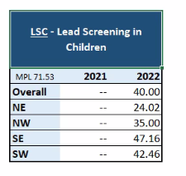

Note that the national average is 71.53%.

For a detailed, recorded presentation on the clinical, public health and regulatory aspects of the lead screening (with CME available): [see our website](https://partnershiphp.webex.com/ec3300/eventcenter/enroll/register.do?siteurl=partnershiphp&formId=209933832&confId=209933832&formType=1&loadFlag=1&eventType=1&accessType=viewRecording&internalPBRecordTicket=4832534b00000004863237399e64aab3b4fdfb4d741cfb1f221f12c57721d8f40933e07dc62a2169).

Vaccination Rates in Pregnancy:

For deliveries billed in 2022:

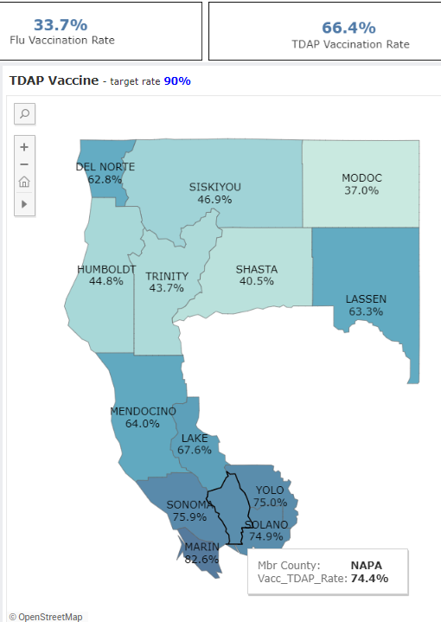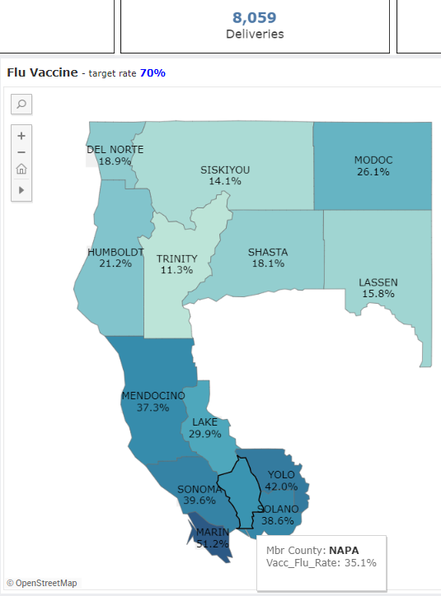

Trends:

In 2021, the plan-wide rates were higher for both: 38.3% for Flu and 68.0% for TDAP.

Pre-COVID, in 2019, the plan-wide rates were 39.5% for influenza and 66% for TDAP.

This is a new HEDIS measure for 2023.

# Clinical Updates

USPSTF Major Updates

Each year PHC’s Quality Utilization Advisory Committee reviews the adult preventive care recommendations of various organizations and updates [Attachment A](https://www.powerdms.com/public/PHC/documents/1858150) of our Adult Preventive Services Guideline. The updated version will be posted to our website in about a week. Here are the major changes:

* + - 1. Aspirin for Primary Prevention of Cardiovascular Events. In April 2022, the USPSTF updated its recommendation to reflect the findings of the January 2019 meta-analysis, which generally found no net benefit. Class C recommendation if 10% ten year cardiovascular disease risk. Otherwise Class D recommendation.
      2. Two different screening algorithms are now used for screening for syphilis, either starting with an RPR or with a treponemal test, and confirming with the other test.
      3. Specific risk factors for screening women for Chlamydia and Gonorrhea after age 25 are listed: previous or current STI, a new or >1
         1. sex partner, a sex partner who has other sex partners,
         2. a sex partner with an STI, inconsistent condom use when indicated,
         3. a history of exchanging sex for money or drugs
         4. a history of incarceration

## Hepatitis B Vaccine Now Recommended for All Adults

Advisory Committee on Immunization Practices (ACIP) now recommends Hepatitis B vaccination for all adults 19-59 years of age regardless of risk factors. Hepatitis B vaccination continues to be recommended for adults 60 years of age or older with risk factors including chronic liver disease, HIV infection, sexual exposure risk, injection drug use, incarceration, or percutaneous or mucosal risk for exposure to blood. For additional information about the HepB vaccine recommendations, providers may refer to the [Universal Hepatitis B Vaccination in Adults Aged 19–59 Years: Updated Recommendations of the Advisory Committee on Immunization Practices](https://www.cdc.gov/mmwr/volumes/71/wr/pdfs/mm7113a1-H.pdf) - United States, 2022, published in the MMWR, which is available on the CDC website.

On a related note, effective January 1, 2022, [Assembly Bill (AB) 789 (Low, Chapter 470, Statutes of 2021](https://leginfo.legislature.ca.gov/faces/billPdf.xhtml?bill_id=202120220AB789&version=20210AB78994CHP)) requires primary care providers in California to offer screening tests for hepatitis B and hepatitis C to adult patients based on the latest screening indications recommended by the United States Preventive Services Task Force (USPSTF), to the extent these services are covered under the patient’s health insurance unless certain conditions apply that include, among others, the patient lacks the capacity to consent to the screening test.

The law also stipulates that patients whose test results are positive for hepatitis B or C infection should be referred for follow-up care with their primary care provider or a liver specialist and those who test negative for hepatitis B and have not been previously vaccinated should be offered hepatitis B vaccination. More detailed information about the new law is available in a [March 22, 2022, letter from CDPH](https://urldefense.com/v3/__https:/ab1ee995966d418da4b12a48bc7a4390.svc.dynamics.com/t/t/Yj3scwarRYMtuDOI4RpBV1Owyjx3gkAXO92uzUVuDrcx/fU7PNDlwRuqx6dMr5xsVlIK5qnqrtqpDhj9FWZGs2Aox__;!!LQC6Cpwp!oq8YSkYoJ6Mh_qZBEB0RKoIrb20iV5bGww-Ux77K4PXUdij399Z4lHYTeKr2FQcePRLkkwpBBrUi9OmCpzdC-EclX-ptKMPyNU6F0Q$).

## Updated Recommendations for Pneumococcal Vaccinations in Adults

ACIP has updated and simplified their pneumococcal conjugate vaccination (PCV) regimen recommendations after both a 20-valent PCV (PCV20) and a 15-valent PCV (PCV15) were licensed by the U.S. Food and Drug Administration (FDA) in 2021 for use in adults 18 years of age or older.

ACIP now recommends use of either PCV20 alone or PCV15 in series with PPSV23 for all adults 65 years of age or older and for adults between 19 and 64 years of age with certain underlying medical conditions or other risk factors who have not previously received a PCV or whose previous vaccination history is unknown.

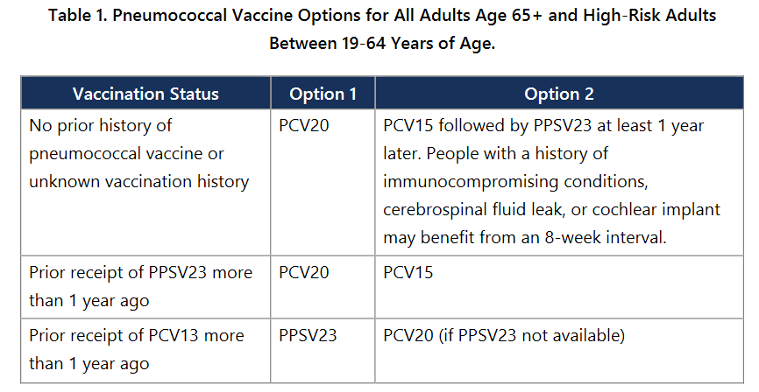

For additional information about the PCV recommendations for adults with specific underlying medical conditions or other risk factors, providers may refer to the [Use of 15-Valent Pneumococcal Conjugate Vaccine and 20-Valent Pneumococcal Conjugate Vaccine Among U.S. Adults: Updated Recommendations of the Advisory Committee on Immunization Practices](https://www.cdc.gov/mmwr/volumes/71/wr/pdfs/mm7104a1-H.pdf) - United States, 2022, published in the MMWR, which is available on the CDC website. While on the CDC website, providers may also find the [Pneumococcal Vaccine Timing for Adults](https://www.cdc.gov/vaccines/vpd/pneumo/downloads/pneumo-vaccine-timing.pdf) resource to be a useful guide.

## Cognitive Health Assessments Required Annually for Patients over age 65

The California Legislature passed a bill requiring that all patients age 65 or older receive an annual cognitive health screening to detect early dementia. This went into effect on July 1, 2022. This week, DHCS released draft policy language about this requirement. Here are some highlights.

1. For Medi-Cal beneficiaries over the age of 65 who do not have MediCare, a CPT2 code (1494F) has been designated to be used to indicate that such a cognitive screening was performed. If billed with the visit, an enhanced payment will be paid on a fee for service basis.
2. DHCS has a mandatory training that must be completed by clinicians wishing to be paid for billing 1494F. This training can be accessed at: [www.dementiacareaware.org](http://www.dementiacareaware.org) .
3. DHCS has added additional options for which cognitive assessment tools may be used. Early options presented included the mini mental status exam (MMSE) and the St. Louis University Mental Status Exam. The draft policy change added the General Practitioner Assessment of Cognition (GPCOG), the Mini-cog, the Informant Interview to Differentiate Aging and Dementia, and the Short Informant Questionnaire on Cognitive Decline in the Elderly. PHC is assessing these options and will make specific recommendations in future newsletters.

Pediatric Well-Child Care Screening Tools

Effective 1/1/23, DHCS no longer requires use of the Staying Healthy Assessment (SHA) tool for Initial Health Assessments. It is not a required tool for on-going well-child care visits. Nonetheless, pediatric and adolescent well care visits should include evaluation of physical health (including medical history, growth/nutrition, safety, physical activity and oral health, immunizations and age-appropriate lead testing). In addition, quality preventive care also includes evaluation of development, social/emotional health, mental health, and risk behaviors, using age-appropriate screening tools.

As part of its well child care toolkit, the American Academy of Pediatrics (AAP) provides a listing of “[Instruments for Recommended Universal Screening at Specific Bright Futures Visits](https://publications.aap.org/toolkits/resources/15625/?autologincheck=redirected).”

Although it is not a comprehensive list, it does include a number of commonly used instruments. We encourage you to visit this site if you are looking for screening tools for your practice. The ideal tool will be well-tested, available in multiple languages, and easy to seeing children and adolescents. A few examples are listed below.

[Bright Futures Tool and Resource Kit](https://publications.aap.org/toolkits/pages/bright-futures-toolkit?_ga=2.66052846.1762842884.1677684317-536363850.1677684316)

This is the well-established AAP comprehensive toolkit for well child care. Each WCC visit template includes an age appropriate history, physical exam, nutrition questions and developmental milestone checklist, as well as safety and social determinants of health-related questions. The template prompts the provider to use screening tools as appropriate for age, such as those listed below. The screening tools themselves are not built into the visit template. Parental handouts are available in 14 languages. The Bright Futures Tool and Resource Kit is available for a fee.

### Screening Tool Highlights

The Survey of Well-being of Young Children (SWYC)

This tool is included on the AAP screening tool list for children 0-65 months. It contains general developmental screening (Milestones portion), Behavioral Screening (Baby Pediatric Symptom Checklist and Preschool Pediatric Symptom Checklist) and Autism screening (Parents Observation of Social Interactions portion), in a single screening tool. In addition, it includes Edinburgh screening questions for post-partum depression and a few ACES-related questions around substance use in the home and parental discord. It is available in 19 languages and is available free-of-charge. This tool would not provide full ACES screening.

Patient Health Questionnaire-A (PHQ-9 Modified for Teens)

This tool is included on the AAP screening tool list for depression in children 11-21 years of age. It contains 13 questions and is simple to score. It is free and available in more than 30 languages.

Car, Relax, Alone, Forget, Trouble Questionnaire (CRAFFT 2.1+N)

This tool is included on the AAP screening tool list for children 11-21 years of age. It screens for substance use including tobacco, alcohol and other drugs. It also includes vaping. The tool is available in more than 30 languages and is free of charge.

### Coding For Pediatric Screening

|  |  |
| --- | --- |
| Screening | Code |
| Screening for drug use disorder (other than tobacco and alcohol)) | H0049 |
| Alcohol Misuse Screening | G0042 |
| Tobacco Screening | 4004F |
| ACES: Negative Screen | G9920 |
| ACES: CPT G9919 - positive (4+) and recommended f/u | G9919 |
| Developmental Screening | 96110 |
| Autism Screening | 96110 w/ modifier KX |
| Mental Health/Depression Screening | 96127 |

Understanding PHC Requirements for Glucose Monitors and Insulin Pump therapy for Diabetes

### Part I: Glucose Monitoring: When is Continuous Glucose Monitors Indicated?

Clinical Scenario: A 57-year-old patient with type 2 DM (T2DM), with a Hemoglobin A1c of 8.2, taking metformin they report seeing an advertisement on television for a Continuous Glucose Monitor (CGM). She checks her blood sugar twice a day (once fasting, and the other time as various times in the day) and has no recorded episodes of hypoglycemia. She requests a prescription for a CGM. Is a CGM clinically indicated in this patient?

Glucose monitoring is a controversial aspect of diabetes care. The ADA Standard of Medical Care in Diabetes suggests that glucose monitoring allows patients to evaluate their individual response to therapy and assess whether glycemic targets are being safely achieved. Integrating results into diabetes management can be a useful tool for guiding medical nutrition therapy and physical activity, preventing hypoglycemia, or adjusting medications (particularly with insulin dosing). Blood Glucose Monitoring (BGM) is most effective when used in conjunction with a treatment plan that adjust treatments based on BGM values. Individual patient’s needs and goals should dictate frequency and timing of BGM use.

For individuals with T1DM and insulin treated T2DM, frequent BGM is an essential component of glycemic management. The BGM readings are used throughout the day to limit hyperglycemia and prevent hypoglycemic episodes. Individual BGM routines are based on insulin regimen, activities and food or drink intake. Patients work closely with medical providers and RDs/CDEs to drive treatment adjustments that improve blood sugar control.

In the setting of T2DM managed with oral agents only, the role of using BGM has not demonstrated significant impact on overall A1C control. However, one can see the benefit of using BGM in patient education to demonstrate the mechanics of diabetes, nutrition and activity on blood sugar levels. For these patients, frequent daily blood sugar testing is not needed unless there are circumstances that place them at risk for hypoglycemia.

Glucose meters meeting FDA guidance for accuracy provide the most reliable data to support glycemic management. PHC members can access blood glucose monitors and supplies through the Medi-Cal Rx medication program.

A Continuous Glucose Monitor (CGM) is a device that continuously measures and stores glucose levels. It can be used for short periods to answer a diagnostic question, or long term for home blood glucose management.

A short-term (7-14 day) monitor can be set up in the clinician office and used to understand an individual’s trends and patterns in glycemic control for this period. This “snap shot” of information is used by the clinician and patients to develop the treatment plan. There are specific CPT codes for billing professional services associated with this approach.

Long-term CGMs are used to direct day-to-day management of blood sugar levels in the setting of intensive insulin management plans. The medical provider, RD/CDE and individual use CGM readings to track trends and patterns to direct the overall treatment plan. Research-based evidence suggests the most impactful use of CGM occurs in the setting of intensive insulin treatment regimens or with insulin pumps, which is most commonly used in patients who have T1DM. For most of those with type 1 diabetes, frequent testing of glucose levels is necessary to achieve A1C targets safely without frequent or severe hypoglycemia. Self-monitoring allows adjustments of doses and timing of insulin as well as the timing and content of meals and snacks based on immediate feedback of glucose results. Many people with type 1 diabetes use a combination of blood glucose monitoring (BGM) by finger stick with a glucose meter in addition to CGM, when available.

Whatever the device used, all patients with diabetes should be taught how to use BGM data to adjust food intake, physical activity, or pharmacologic therapy to achieve their specific goals. The ongoing need for and frequency of BGM should be reevaluated at each routine visit to ensure its effective use.

Part II: Continuous Insulin Infusion  
Continuous Subcutaneous Insulin Infusion (CSII) aims to provide a near physiologic insulin replacement using a pump. It requires close monitoring for dose adjustments and relies on frequent glucose monitoring. Insulin pumps are small computerized devices that deliver insulin as steady continuous basal dosing and insulin boluses as needed. Insulin pumps are a tool for managing diabetes in individuals with intensive insulin regimens, such as found in T1DM but rarely in T2DM. Some insulin pumps can receive glucose data from CGM devices.

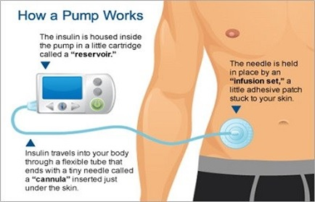

Figure Photo Courtesy of [NHS Chelsea and Westminster Hospital – NHS Foundation Trust](https://www.chelwest.nhs.uk/your-visit/patient-leaflets/medicine-services/troubleshooting-continuous-subcutaneous-insulin-infusion-csii)

What PHC is Looking for in TAR Requests for CGMs and Insulin Pumps  
When ordering a Continuous Glucose Monitor or Insulin Pump for a PHC members with diabetes, a treatment Authorization Request (TAR) will be reviewed by PHC staff for medical necessity. Please submit the following information for a TAR at PHC:

* Clinician Order from the treating provider: NP/PA/MD/DO
* Most recent HgbA1C result
* Chart notes:
* From the clinician managing the member’s diabetes: PCP, Diabetologist, Endocrinologist and CDE where applicable.
* Include diagnosis with the type of diabetes.
* Must include chart notes stating the need and justification for insulin pump or continuous glucose monitor as part of the member’s plan of care in managing his/her DM.
* Should address the member’s level of engagement in self-management and diabetes care – BGM testing should be at least 3 to 4 times per day.
* Recent Blood Sugar Log for 30 days of self-testing OR documentation from provider that member checks blood glucose at least 3 to 4 times per day.
* For member with T1DM, documented adherence to a clinician-ordered diabetic treatment plan.

For T2DM, documentation of the frequency of severe hypoglycemia, nocturnal hypoglycemia, or poor diabetes control in spite of good adherence to medication therapy. .

**Back to the patient…**

The patient presented above is not a good candidate for either a short term or long term Continuous Glucose Monitor. She has type 2 DM, is not using insulin, and while the A1C is suboptimal, this does not indicate poor control. There is no mention of episodes of extreme hyperglycemia or hypoglycemia. She is a good candidate for additional diet/lifestyle education (RD or CDE) and optimization of the medication therapy.

## Foot Care for Patients with Diabetes: Using Partnership Benefits to Decrease Amputations and Ulcerations

Comprehensive foot care is essential to maintaining mobility and activity in the setting of chronic diabetes management. Individuals with poor foot care are at high risk for ulcers, infection and amputation. Most preventive foot care can take place during routine visits with exams and foot filament testing. Stock orthopedic shoes can be used to prevent complications in individuals with diabetes. PHC covers stock orthopedic shoes for member with diabetes when these are medically necessary especially in the following circumstances: neuropathy (noted with foot filament testing), current or past foot ulcers, amputation or foot deformity. Custom orthopedic shoes may be considered when the patients’ footwear needs cannot be met with stock orthopedic shoes. Stock or custom orthopedic shoes can be ordered through PHC contracted vendors who submit a TAR with a prescription and chart notes from a medical or podiatry provider showing the medical need for these items.

For patients whose foot care needs cannot be managed in the primary care office, referral to podiatry may be needed for management of callouses, ulcers and nail care. The PHC network of contracted podiatrists in your area may be found in the PHC Provider Directory on the PHC website: <http://www.partnershiphp.org/Providers/Medi-Cal/Pages/Provider-Directory.aspx>

## Treatment Resistant Urethritis or Cervicitis? Consider Possibility of *Mycobacterium genitalium*

Source: [CDC](https://www.cdc.gov/std/treatment-guidelines/mycoplasmagenitalium.htm)

*M. genitalium* causes symptomatic and asymptomatic urethritis among men and is the etiology of approximately 15% - 20% of NGU, 20% - 25% of non-chlamydial NGU, and 40% of persistent or recurrent urethritis.

Among women, *M. genitalium* has been associated with cervicitis, PID, preterm delivery, spontaneous abortion, and infertility, with an approximately twofold increase in the risk for these outcomes among women infected with *M. genitalium*.

See the [CDC web page on *M. Genitalium*](https://www.cdc.gov/std/treatment-guidelines/mycoplasmagenitalium.htm)for information on diagnosis and treatment. The first line treatment is Doxycycline for 7 days for uncomplicated infection and 14 days for pelvic inflammatory disease.

Clinical Practice Guidelines for Primary Care

Partnership has posted clinical practice guidelines for adult and pediatric preventive care, depression, chronic pain management, diabetes management, lactation management, and asthma management on our website at: <http://www.partnershiphp.org/Providers/Policies/Pages/ClinicalPracticeGuidelines.aspx>

# Health Services Updates

## Transportation Benefit Changes for PHC Members

To improve the service quality of transportation services provided to our members, effective April 1, 2023, PHC will be directly managing the companies providing transportation of our members. A new toll-free number for Transportation Services, (866) 828-2303, will go live on March 20. Providers can email [transportationhelpdesk@partnershiphp.org](mailto:transportationhelpdesk@partnershiphp.org). Please make sure your case managers and others that help members with transportation are aware of these new methods to arrange transportation!

## Genetic Testing

The number of genetic tests available is growing rapidly, as is the complexity of deciding which test to order and how to interpret the results. While the prices are starting to drop, they are still very expensive, and we find that many clinicians are ordering the wrong tests for the wrong reasons. Thus, these lab tests often require a Treatment Authorization Request (TAR) to be paid.

While most are typically ordered by specialists, tests for hereditary cancer and pediatric developmental disorders are increasingly being ordered by primary care clinicians. Note that prenatal screening tests are covered directly by the [California Prenatal Screening](https://www.cdph.ca.gov/Programs/CFH/DGDS/pages/pns/default.aspx) [program.](https://www.cdph.ca.gov/Programs/CFH/DGDS/pages/pns/default.aspx)

To view the list of tests that [require prior authorization](https://www.powerdms.com/public/PHC/documents/1850162) and to view the [most recent form](https://www.powerdms.com/public/PHC/documents/1850166) for screening for familial genetic syndromes, see the [genetic testing policy addendum](https://www.powerdms.com/public/PHC/documents/1850162).

Another resource for the large majority of our network that uses Quest Diagnostics is to contact Quest’s genetic counselors to get advice on the correct test to order for a patient’s particular circumstances. The phone number is: 1-866-GENE-INFO (1-866-436-3463).

## Options for Accessing Diabetes Education and Nutrition Counseling for Your Patients with Diabetes

Diabetes education and nutrition counselling are a necessary component to diabetes care that gives patients an opportunity to better understand their condition and master the tools needed to manage nutrition, activity, and medications. The American Diabetes Association recommends that all people with diabetes participate in diabetes self-management and education to support better outcomes.1 Patients with diabetes require these services to receive the support needed and gather knowledge that improve decision-making for diabetes self-care.

This aspect of diabetes management (DM) care is difficult to fit into the standard 15-minute PCP visit. Referrals to Registered Dietitians (RDs) and Certified Diabetes Educators (CDEs) offer your patients focused consultations to move the dial on glycemic control through health education and self-management using motivational interviewing and other standardized tools.

To support you and your patients’ efforts to manage diabetes, PHC covers Medical Nutrition Therapy for both diabetes and prediabetes. Please use PHC resources to integrate Nutrition and Diabetes Education with RDs and CDEs from the PHC network to optimize care and improve glycemic control in your patients with diabetes.

Medical Nutrition Therapy (with a PHC credentialed CDE or RD) that takes place in the PCP office, with community RD or CDE in person or via telehealth, is a covered PHC benefit. If your practice does not offer these services, your patient can access Medical Nutrition Therapy (MNT) within the PHC network of specialty providers. PHC Network providers for MNT include: *the Northern California Center for Wellbeing* in Sonoma County and *As You Are Nutrition* in Napa County. These practices may offer flexibility for in-person or telehealth visits. Some practices offer individual and/or group visits. Another option, TeleMed2U offers direct telehealth only visits for PHC members over three years old. Direct telehealth visits for members are available with referral to TeleMed2U Nutrition through PHC’s Online Services. Referral coordinators can direct referrals via an eRAF or faxing for MNT using the Provider Directory and the PHC Provider Portal. Please have your referrals team contact your local PHC Provider Relations representative for more information on details of referring to MNT if they are not familiar with these systems.

In addition, the PHC Care Coordination department can assist your patients who need additional assistance navigating the health care system to ensure they are accessing prescribed medications and follow up on referrals to nutrition therapy and other specialty care. You can refer a PHC member to Care Coordination by calling or having the patient call (800) 809-1350 or sending a secure email to [CareCoordination@partnershiphp.org](mailto:CareCoordination@partnershiphp.org). Please provide the patient’s name, date of birth, and contact information for PHC to reach out to the member.

If your patient continues to have challenges meeting glycemic targets in spite of a collaborative approach with medication and lifestyle management (MNT), a referral to an endocrinologist may be needed. A consultation with an endocrinologist may occur in person or via telehealth. The telehealth network is more readily accessible than in-person options. Be mindful that patients who are not collaborative with the treatment plan nor adherent to the medication regimen and MNT recommendations are not likely to benefit from endocrinology consultation. For these patients, continued work with diabetes education, self-management tools, and engagement toward adherence to the current medication and lifestyle regimen has better potential for benefit.

1. ADA Professional Practice Committee: Standards of Care in Diabetes December 2021, Vol.45, S1-S2. doi:<https://doi.org/10.2337/dc22-Sint>

## Care Coordination Services at Partnership

Did you know that Partnership offers comprehensive case management services to all of our members regardless of age or location? Partnership’s Care Coordination department is comprised of RN Case Managers, Medical Social Workers, Health Care Guides, Behavioral Health Clinical Specialists, and Transportation Specialists ready to assist providers, members, and community partners coordinate care and access services.

These services are voluntary, provided at no cost to the member or provider, and the member can opt-out at any time.

Most of our teams’ work is done telephonically, with the possibility of face-to-face engagement in select instances.

When we connect with members, we assign them an Acuity Level that best matches their needs and level of intensity for case management services.

The lowest level is for our members that need help accessing their benefits or providers. The highest levels are for those members that have multiple unmanaged complex conditions and/or for those whom have difficulty navigating the healthcare system without intensive support of a case manager.

If you believe you have a Partnership member that would benefit from the services available from our Care Coordination department, please refer then by calling (800) 809-1350 or e-mailing the Care Coordination Help Desk at:

* Southern Region: [CareCoordination@partnershiphp.org](mailto:CareCoordination@partnershiphp.org)
* Northern Region: [CCHelpDeskRedding@partnershiphp.org](mailto:CCHelpDeskRedding@partnershiphp.org)

## The Intensive Outpatient Palliative Care Benefit

Covered conditions include advanced cancer, advanced liver disease, congestive heart failure, chronic obstructive lung disease, progressive degenerative neurologic disease, or other serious pre-terminal conditions that result in frequent hospitalizations. This benefit is designed for Partnership members with limitations in function and limited life expectancy who are at a late stage of illness who have received maximal member-directed therapy or therapy is no longer effective.

Palliative care local in-person resources vary by county.

Here is the contact information for active and new Palliative Care Provider Organizations in our service area:

|  |  |  |
| --- | --- | --- |
| **Counties Served** | **Organization** | **Referrals** |
| Del Norte, Humboldt, Lassen, Modoc, Siskiyou, Shasta, Trinity, Solano (new county) | Vynca | Phone: 707-442-5683 |
| Humboldt | Hospice of Humboldt (new) | Phone: 707-267-9880 |
| Lake | Hospice Services of Lake County | Phone: 707-263-6270 ext 140 |
| Mendocino | Madrone Care Network | Phone: 707-380-5080 |
| Napa, Sonoma, Solano (Vallejo) | Providence Palliative Care Napa Valley | Phone: 707-258-9080 |
| Marin, Sonoma | Hospice By the Bay | Phone: 415-444-9210 |
| Marin | MarinHealth Medical Network (new) | Pending |
| Sonoma | St. Joseph Health | Phone: 707-522-4307 |
| Yolo | Yolo Hospice | Phone: 530-758-5566 |
| Yolo | Dignity Health - Woodland | Phone: 916-281-3900 |

Eligible patients should have a year or less of life expectancy, not be a candidate for hospice, be in a state of declining health, in spite of medical treatment.

# CMO Updates

The following articles are extracted from the Partnership Primary care blog: <http://phcprimarycare.org>, containing content from the past 10 years. In addition, an archive of prior Medical Directors newsletters can be found on the [Partnership website](http://www.partnershiphp.org/Providers/HealthServices/Pages/CMO-Newsletters.aspx).

## Providing the Highest Quality of Care with a Shortening Half-Life of Medical Knowledge

Half of all current best practices in medicine will be outdated in about 3-6 years. This article explores what the graph of this decline looks like and what clinicians must do to maintain their expertise over time. [March 2023 newsletter.](https://mailchi.mp/1ab4e7622a90/medical-directors-newsletter-march-2023)

## Shortage of Primary Care Clinicians: Potential Solutions

Presents the results of Partnership’s first ever point-in-time survey of current primary care position openings. Analyzes the underlying drivers of the shortage of primary care providers, and presents strategies to address this. [Jan/Feb 2023 newsletter](https://mailchi.mp/69ce75179e4e/janfeb-2023-medical-directors-newsletter).

## Collaborating to Achieve System Wide Changes

Part I makes the case for all clinical leaders to spend some of their time collaborating to achieve system-wide changes, including becoming more active in county medical societies. PHC encourages all primary care practices to maximize their support of physicians in joining their local county medical society. [October 2022 newsletter](https://mailchi.mp/e80c49fb083b/partnership-healthplan-of-california-medical-directors-newsletter-october-2022).

The California Medical Association (CMA) will give discounted memberships to groups of physicians that join with a commitment to multi-year memberships. The discount applies to the CMA portion of the membership dues; the portion that goes to the local medical society is the same. PHC will use this method to join our medical directors throughout the PHC service area for the next four years. For more information, reach out the CMA Membership Department: [medgroup@cmadocs.org](mailto:medgroup@cmadocs.org).

Part II describes the vital role of local community collaborative effort in improving the underlying drivers of poor outcomes. [November 2022 newsletter](https://mailchi.mp/28e6c6041bce/medical-directors-newsletter-november-2022).

Part III focuses on collaborating with state-wide trade organizations. December 2022 newsletter.

## Looking for Opportunities to Improve

Describes how Partnership uses the Grievance and Peer Review processes to identify ways for the Health Plan and our health care delivery system to continuously improve. Ways these principles can be adopted in all PCP offices are reviewed. [September 2022 newsletter](https://mailchi.mp/a0753fb82e56/phcs-medical-directors-newsletter-september-2022).

## Knowledge Management: Don’t Reinvent the Wheel

Provides a brief introduction to the essential discipline of Knowledge Management, and how to ensure we learn from the past to inform the future, and capture new knowledge for future use. [July 2022 Newsletter](https://mailchi.mp/1e4e1aa7abb7/phcs-medical-directors-newsletter-july-2022).

## The Hazards of Medical Spanglish

Gives some examples of the dangers of providers who speak a little of a foreign language, but not enough to communicate accurately with their patients. Reviews options for translation. [June 2022 Newsletter](http://www.partnershiphp.org/Providers/HealthServices/Documents/Office%20of%20the%20CMO/Newsletters/Weekly/2022/01_Weekly%20MD%20Briefing_June%2013-17%202022.pdf).

## Series on Diagnostic Accuracy

[Part 1:](http://phcprimarycare.org/?p=2540) Introduces the concept of slow and fast thinking described by Nobel Laureate Daniel Kahneman and the notion of cognitive debiasing, where clinicians intentionally shift to slow thinking when the stakes are high.

[Part 2:](http://phcprimarycare.org/?p=2538)  Describes the risk of overthinking clinical scenarios, with resulting over-utilization of diagnostic tests. Summarizes the American College of Physicians principles for accurate diagnosis.

[Part 3:](http://phcprimarycare.org/?p=2362)  Offers a historical framework of four medical epistemologies that clinicians can use to decide on what treatments to offer patients.

[Part 4:](http://phcprimarycare.org/?p=2543)  Describes seven measures and habits that clinicians can use to reduce the likelihood of cognitive biases causing diagnostic inaccuracy or therapeutic errors.

[Part 5:](http://phcprimarycare.org/?p=2601) Describes the five major categories of system issues contributing to diagnostic error, and what can be done to mitigate them.

## Wake up your Mirror Neurons

Describes the mirror neuron system and its role in non-verbal communication and empathy. [May 2022 Newsletter.](http://phcprimarycare.org/?p=2563)

## Clinical Quality Measure Inequities

PHC can use two primary sources to look for plan-wide health inequities:

HEDIS data includes more measures (approximately 50 measures, but Hybrid measures have small denominators making statistical significance for disparities harder to find.

PCP QIP data which is a smaller set of measures, but achieves statistical significance on HEDIS hybrid measures.

### Inequities based on 2021 HEDIS measurement year

Using data from HEDIS Measurement year 2021, assigning the white population as the benchmark, and excluding contraceptive measures, we find 21 ethnicity disparities:

Black/African American population: 5 measures

* 1. Follow up after initiation of Antidepressant Medications (AMM-A and AMM-C). (Note: very incomplete data for these ECDS measures; both proposed for retirement in 2024 by NCQA)
  2. Higher rates of visits to the emergency room (AMB-ED)
  3. Lower rate of well-child visits below 3 years of age (W30-2 and W30-6)

Hispanic population: 5 measures

* 1. Follow up after initiation of Antidepressant Medications (AMM-A and AMM-C). (Note: very incomplete data for these ECDS measures; both proposed for retirement in 2024 by NCQA)
  2. Lower rate of follow up after an ED visit for Alcohol or substance use disorder (both 7 and 30 days), (FUA7 and FUA30)
  3. Lower rate of well child visits from birth to 15 months of age (W30-6)

Native American Population: 11 measures

1. Antidepressant medication management (AMM-A and AMM-C) follow up after initiation of medication for depression, both short term and long term (Note: very incomplete data for these ECDS measures; both proposed for retirement in 2024 by NCQA)
2. Lower rates Breast Cancer Screening (BCS)
3. Lower rates Controlling Blood Pressure (CBP)
4. Lower rates of screening for depression (CDF-18+)
5. Lower rates of developmental screening of infants (DEV)
6. Lower rates of prenatal and postpartum visits (PPC-Pre and PPC-Post)
7. Lower rates of well child visits from 15 months of age to 21 years of age. (WCV and W30-2)
8. Lower rates of documentation of BMI in children (WCC-BMI)

For inequities based on language (non-English language is a surrogate for being first generation immigrants), three of the five Hispanic disparities above were also found to be language disparities.

For other languages with significant inequities:

* The Hmong speaking population (n=730) has a low rate of Breast Cancer Screening (32% vs. 47% in English speakers) and well child visits (34% vs. 42% in English speakers)
* The Tagalog speaking population has low rates of well child visits (35% vs 42% in English speakers) and visits between 15 and 36 months of age (32% vs. 55% in English speakers).
* For screening for depression and follow up in adults, **six language groups** had lower rates than the English speaking population: Hmong, Spanish, Tagalog, Russian, Vietnamese, and Chinese.

### Inequities based on PCP QIP data

QIP data uses a combination of claims data and data entered by sites through eReports.

Disparities affected Black/African American Members (compared to rates in white members)

New Disparity in 2022:

* + 1. Blood sugar control (59% vs. 62% in white population)

Persistent, but improved inequities in 2022:

Adolescent and Well Child Visits: 3% less in Black members

Childhood immunization: 3% less in Black members

Eliminated disparity from 2021 to 2022:

* 1. Well child visits in first 15 months of age
  2. Colorectal cancer screening
  3. Hypertension Control

No Inequities in 2022 (equal rates or rates higher in Black members):

1. Asthma Medication Ratio
2. Retinopathy exam for those with diabetes
3. Breast Cancer Screening
4. Cervical Cancer Screening
5. Adolescent Immunization
6. Nutrition and Physical Activity Counselling

Disparities affecting Native American Population

Eleven measures (out of 12)

1. Asthma Medication Ration (60% vs. 66%)
2. Breast cancer screening (34.4% vs. 45.8%)
3. Childhood immunization (13% vs. 20%)
4. Colorectal cancer screening (27% vs. 36%)
5. Blood pressure control (52% vs. 61%)
6. Blood sugar control (48% vs. 62%)
7. DM Retinopathy screen (30% vs. 38%)
8. Adolescent immunization (19% vs. 21%)
9. Nutrition counseling (35% vs. 57%)
10. Physical activity counseling (41% vs. 55%)
11. Well child visits (48% vs. 55%)

No inequities

* Well child visits in the first 15 months of life

We have identified the major driver of the lower measures for the Black population being in larger providers in Solano County, and the largest driver of the lower measures in the Native American population being the twelve contracted tribal health centers in our region. PHC has strategies for addressing these inequities. Our equity goal is to eliminate at least 25% of inequities each year, while our quality goal continues to be to increase overall performance in measures scoring below average for other Medicaid health plans.

Planned interventions to achieve these goals are to incorporate elimination of a disparity into the 2024 PCP QIP core measure set, to share data will providers on their priority disparities, offer training on using a QI approach to eliminating disparities, and health plan level interventions including direct member outreach, leadership engagement activities, and applying the Health Equity/Practice Transformation planning and implementation grants coming from DHCS to support this work.

For provider trainings on Health Equity, see internal training and external training, below.

# Quality Improvement Updates

## Hospital OB Measures, 2021

Data from Cal Hospital Compare. Includes hospitals in new Eastern Region.



Green and red ratings by Cal Hospital Compare

Hospitals noted as “average” but with a relatively high C-section rate are shown in orange.

Special note: Fairchild Medical Center’s C-section rate decreased from being one of the highest to being one of the lowest, between 2020 and 2021.

Only MarinHealth scored above average in all measures.

# Pay for Performance Program for Primary Care (PCP QIP)

## PCP QIP Measures for 2023

**(A) Core Measurement Set Measures**

Providers have the potential to earn a total of 100 points in four measurement areas: 1) Clinical Domain; 2) Appropriate Use of Resources; 3) Access and Operations; and 4) Patient Experience. See [detailed specifications](http://www.partnershiphp.org/Providers/Quality/Documents/QIP%202023/2023%20PCP%20QIP%20Measure%20Specifications_Website%20Version_Final_Revised_3.16.2023.pdf) on our website.

**Relative Improvement**

* A site’s performance on a measure must meet the 50th percentile target in order to be eligible for RI points on the measure **and** have a 10% RI score

**PCPs Serving Both Children and Adults**

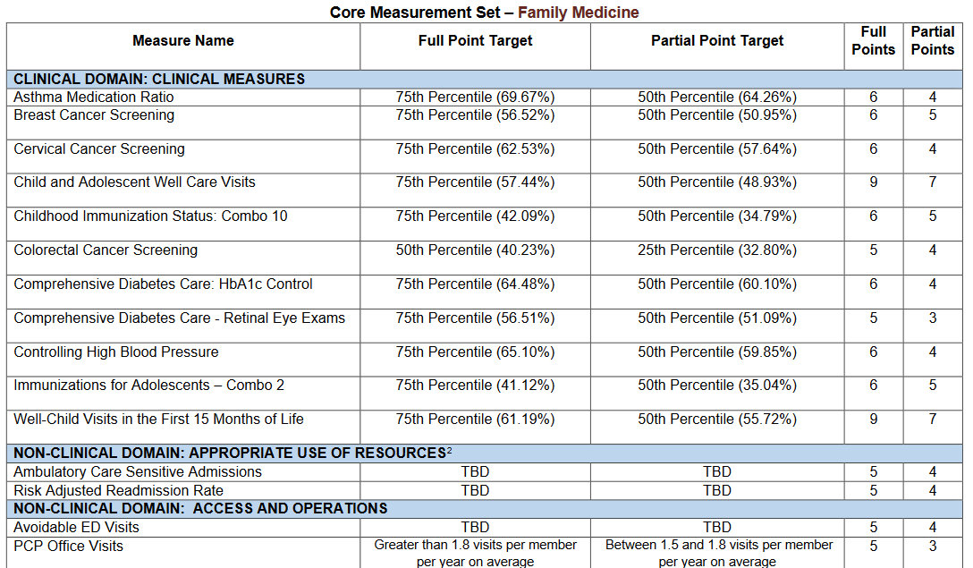

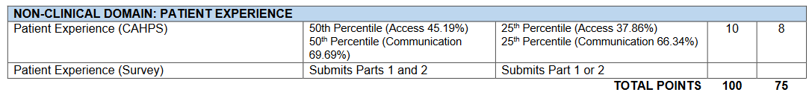

**(B) Unit of Service Measures**

Providers receive payment for each unit of service they provide.

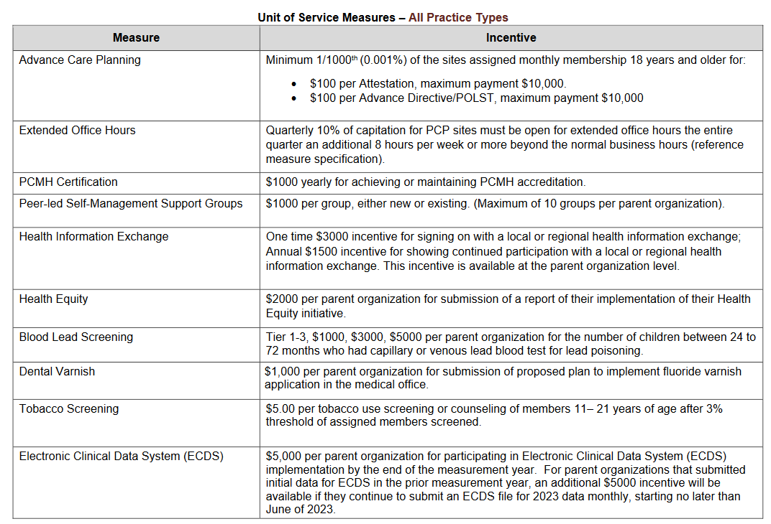

# Calendar for Focusing on Measures

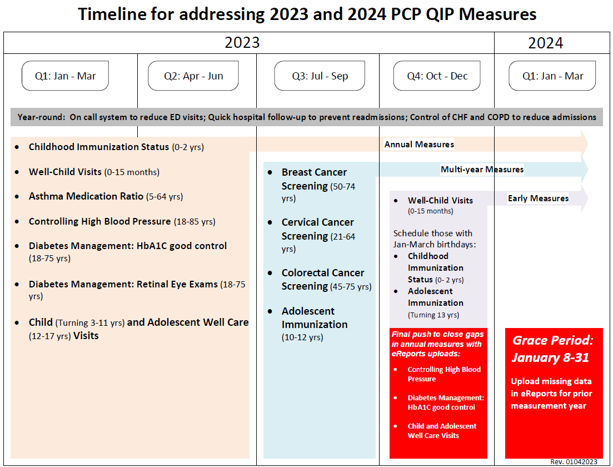

# Specific Support for Priority Quality Measures

## Flu vaccination key to improving CIS-10 vaccination rates!

Everyone involved in pediatric care knows how challenging it is to meet the current immunization measures. Across the PHC network, Childhood Immunization Status (CIS-10) rates are low, sometimes in the teens.  
  
Upon analyzing our own data, the most challenging immunization requirement to meet is the two influenza vaccinations. A sample of our data (just under 10,000 members under two years old) only found 30.59% of our members fully met the CIS-10 measure. An additional 4.3% would have met the CIS-10 measure with only one additional influenza vaccination and another 7.7% needed two influenza vaccinations to meet the CIS-10 measure. Certainly, Covid has made these measures more challenging (combined with the lack of an actual flu season in 2020-21) but influenza vaccination rates have always lagged behind other vaccines.  
  
Our analysis also showed some other interesting findings. Only 3% of pediatric members received all required vaccines, except for one Hep B vaccination dose! Another 4.5% were missed due to only lacking sufficient Rotavirus vaccinations. Just under 1% each were missing the full DTaP or PCV series.  
Some best practices that may help with some of these rates:

* If you have not already switched to the newer Vaxelis vaccine, this may be a good time to do so. Vaxelis is similar to the Pentacel and Pediarix, except it includes BOTH HepB and Hib. This may help with those missed HepB doses.
* It may also be time to switch to the 2-dose rotavirus vaccine, Rotarix. This will give some flexibility in catching up on a missed dose.
* Lastly, use the Immunization Dose Reports from our Partnership Quality Dashboard (PQD) throughout the measurement years and focus on the 18- to 2-month population to ensure they have received all four PCV and DTaP immunizations.

## Testing for Streptococcal Pharyngitis

The standard of care for treatment of streptococcal pharyngitis is to confirm infection with a rapid strep test or throat culture prior to prescribing antibiotics, or at the latest concurrent with antibiotic treatment.

Both [UpToDate](https://www.uptodate.com/contents/treatment-and-prevention-of-streptococcal-pharyngitis-in-adults-and-children?search=streptococcal%20pharyngitis&source=search_result&selectedTitle=1~102&usage_type=default&display_rank=1) and the [Cochrane Library summary](https://www.cochranelibrary.com/cdsr/doi/10.1002/14651858.CD012431.pub2/full) support this standard.

NCQA has a HEDIS measure that looks at the lack of any strep test associated with antibiotic prescription for strep pharyngitis, called “Appropriate Testing for Pharyngitis” or CWP. Nationally, the 33rd percentile for this measure is 73% percent in Medicaid.

The rate of testing is far lower for Partnership members. The overall rate is just 53%, which is far below the 33rd percentile. The rate did drop about 20% during the Covid pandemic, likely a product of the increased use of virtual visits, and hesitation to send patients to the office or a lab for confirmatory testing. We will have data on 2022 soon, but we ask you all to create processes to allow strep testing even if visits are done virtually.

## COPD Exacerbation Management

Key Points from the 2022 Global Initiative for Chronic Obstructive Lung Disease (GOLD) report for management of exacerbations include:

* Systemic corticosteroids can improve lung function (FEV1), oxygenation and shorten recovery time and hospitalization duration. Duration of therapy should not be more than 5-7 days.
* Short-acting inhaled bronchodilators (usually a combination of beta adrenergic agent like albuterol with a muscarinic antagonist like ipratropium) are recommended as initial treatment of an acute exacerbation. Long acting bronchodilators should be continued if the patient is using them at baseline, but GOLD does not recommend adding long acting bronchodilators for acute exacerbations of COPD. This is in contrast with asthma exacerbations, in which quick acting but long-lasting formoterol containing MDIs are an option.
* Maintenance therapy with long-acting bronchodilators should be initiated as soon as possible before hospital discharge.

## Statin Therapy Lagging in Patients with Cardiovascular Disease or Diabetes

In 2021, about 35% of Partnership members with diabetes were not being prescribed recommended cholesterol-lowering medications. For patients with diagnosed cardiovascular disease, about 17% had not received statin therapy.

In formal studies of other populations, the patients not on statins (where statin therapy was indicated:

1. 60% of those not taking statins were not offered them by their doctor/clinician. This study found that women and African American/Black patients were less likely to have been offered statin therapy, suggesting possible underlying bias.
2. 30% had been on treatment and discontinued therapy. Most of these expressed a willingness to reconsider therapy with another medication.
3. 10% had declined statin therapy.

The Partnership Pharmacy team is meeting with PCP sites with a list of patients who are not taking statin therapy, part of our focused academic detailing program. If you are interested in having the pharmacists visit, please contact your regional medical director who will pass on the request to the pharmacy team.

Here is a summary of best practices for adding appropriate statin therapy and improving adherence for patients with diabetes and/or cardiovascular disease:

1. Members who do not tolerate one statin may be able to tolerate a different statin.
2. Consider statins with fewer drug interactions, such as rosuvastatin, pravastatin, and fluvastatin.
3. Review medication list to confirm a statin has been prescribed when indicated.
4. Provide patient education: explaining goals of statin therapy and need for adherence.
5. Prescribe statins as 90 day supplies, once therapy is stable.
6. Ask your patients open-ended questions to monitor for adverse drug reactions, drug-drug interactions, and other obstacles that may hinder medication adherence.
7. Collaborate with dispensing pharmacies to identify and address medication adherence gaps.
8. Specific medication recommendations:
   1. For high intensity statin therapy (lowers LDL-C by >50%), consider atorvastatin 40-80 mg or rosuvastatin 20-40 mg.
   2. For moderate intensity statin therapy (lowers LDL-C by 30% to <50%), consider atorvastatin 10-20 mg, rosuvastatin 5-10 mg, or simvastatin 20-40 mg.

Thanks for passing this along to your front line clinicians.

# Other Quality Updates

## Developmental Screening

Payments took **effect on January 1, 2020**. FQHCs, RHCs, Tribal Health and other PPS providers are eligible, but they **MUST bill with a Type 1 (individual NPI) in one of the available fields (rendering, ordering, prescribing, billing) or they will not be paid!** This incentive is paid through claims, but the incentive payment will supplement the usual fee for these services.

* 1. Developmental screening:
     1. Paid based on use of CPT code: 96110, without a modifier, once for each age group: 2 month-1 year old, 1 - 2 years old, and 2 - 3 years old.
     2. Rate: $59.50
     3. Nine standardized tool options as defined in CMS Core Measure Set Specifications (not the same as AAP). Most commonly used is the Ages and Stages Questionnaire (ASQ). Effective January 1, any claim for 96110 without a KX modifier MUST be for the use of one of these nine specified tools.
     4. Any other tool used (such as the MCHAT for autism screening), must add a KX modifier. These will be paid the usual claim rate, but not be eligible for the bonus payment. **Early audits are showing that many providers are neglecting to use the KX modifier for autism screening.**
     5. **Early audits also indicate many providers continue using the MCHAT screening tool, which is not approved for use by DHCS. The approved tools include the following:**
        1. Ages and Stages Questionnaire (ASQ) - 4 months to age 5
        2. Ages and Stages Questionnaire - 3rd Edition (ASQ-3)
        3. Battelle Developmental Inventory Screening Tool (BDI-ST) - Birth to 95 months
        4. Bayley Infant Neuro-developmental Screen (BINS) - 3 months to age 2
        5. Brigance Screens-II - Birth to 90 months
        6. Child Development Inventory (CDI) - 18 months to age 6
        7. Infant Development Inventory - Birth to 18 months
        8. Parents’ Evaluation of Developmental Status (PEDS) - Birth to age 8
        9. Parent’s Evaluation of Developmental Status - Developmental Milestones (PEDS-DM)

## Audit Shows Many Child-Health Providers Misuse of Developmental Screening Code

Four years ago, DHCS set new rules around the use of CPT Code 96110 to

document comprehensive developmental screening. More than half of pediatric and family medicine providers (audited by Partnership in 2021) had not performed a comprehensive developmental screening when the 96110 code was used. While several developmental screening tools are allowed, the most commonly used is the Ages and Stages Questionnaire (ASQ).

In most cases, the charts associated with use of the 96110 code documented a screening for autism, neglecting to use the required .KX modifier when the 96110 was used to document the narrower autism screening, with a tool such as the M-CHAT. Prior to 2019, the modifier was not required for autism screening; an educational campaign about the new modifier was conducted in 2019, but not all pediatric providers made the needed changes.

When autism screening is provided, in addition to a comprehensive developmental assessment, both 96110 without a modifier and 96110.KX may be billed together.

A comprehensive developmental screen is considered standard of care by the American Academy of Pediatrics, the American Academy of Family Physicians, CMS, NCQA, and DHCS. Please ensure your well-child visit process and templates include the use of a comprehensive tool such as the ASQ and documents this appropriately with 96110.

Like ACES screening, developmental screening is carved out of the PPS reconciliation process, so an additional $59.50 is paid when a comprehensive developmental screen is done, regardless of provider type. Many FQHCs are not billing 96110 at all, meaning either that they are doing developmental screening but giving up the revenue from doing so, or they are not following standard of care for pediatric preventive care. Either should be remedied. We ask Medical Directors and CEOs to take a lead in this.

## ACEs Screening

Payments took effect on January 1, 2020. FQHCs, RHCs, and Tribal Health centers are eligible, but they MUST bill with a Type 1 (individual NPI) in one of the available fields (rendering, ordering, prescribing, or billing) or they will not be paid! This incentive is paid through claims; the incentive payment will supplement the usual fee for these services.

1. ACEs screening:
2. Rate: $29 each
3. Paid based on use of the following code:
   * + 1. G9919: Screening performed and positive and provisions of recommendations (4 and greater)
       2. G9920: Screening performed and negative (0 to 3)
4. Children up to age 19
   1. PEARLS (Pediatric ACEs and Related Life-events Screener; includes screening for several social determinants of health)
      * 1. Up to every 1 year
        2. Parents may complete age 0-19; child may answer ages 12-19
   2. Adults ages 18 to age 65: ACES screening tool, once in a lifetime per provider per patient; OK to repeat for new provider.
   3. Age 18 and 19: either tool can be used.
   4. DHCS has [posted translations](https://www.acesaware.org/screen/screening-tools-additional-languages/) of these tools.
   5. Providers must complete a 2 hour training and attest to completion of the training to be eligible to be paid the supplemental payment! Training available at: [www.acesaware.org](http://www.acesaware.org)

California is dedicating Proposition 56 tax revenue to cover a variety of Medi-Cal services and incentives, including incentives for screening for Adverse Childhood Events (ACEs) and Developmental screening of 1-3 year olds. Unlike other incentive programs, all provider types, including Federally Qualified Health Centers (FQHCs), Rural Health Centers (RHCs) and Tribal Health Centers, are entitled to keep the incentives for ACEs ($29 each) and Developmental screening ($59 each), which started on January 1, 2020.

We strongly encourage PCPs caring for children who are not fully taking advantage of these screening dollars to look at their systems and see if they can adapt them to capture this source of revenue.

# Upcoming Educational Events

## Partnership Sponsored Events

### Equity in Health Care

Together with CPS HR Consulting, the PHC Improvement Academy, is hosting a training series in which health care leaders will have the opportunity to engage in discussions to promote a greater understanding of health equity and equip them with concrete strategies to incorporate and advance health equity within their organizations.

Target Audience: Organizational leaders who are change-facilitators in their system.

Attendance: Commitment to attend all three sessions is mandatory and is limited to one individual per organization within the Partnership network. AAFP CME and BRN CE will be offered for attending this series.

**Session 1 of 3: Implicit Bias**

June 13, 2023, Noon – 2 p.m.

**Session 2 of 3: Defining Health Equity and Strategies to Improve Organizational Practices**

July 18, 2023, Noon – 2 p.m.

**Session 3 of 3: Toolkit to Support Health Equity Practices**

August 15, 2023, Noon – 2 p.m.

Due to limited seating, there is a brief application process required for approval to attend these sessions.

[Click Here to Complete the Application](https://www.surveymonkey.com/r/EquityInHealthCareTrainingSeriesApplication2023)

Please contact [improvementacademy@partnershiphp.org](mailto:improvementacademy@partnershiphp.org) if you have any questions.

### ABCs of Quality Improvement

The ABCs of Quality Improvement (QI) is a virtual training designed to teach you the basic principles of quality improvement. The five-session course covers the followings topics:

* + What is quality improvement?
  + Introduction to the Model for Improvement​
  + How to create an aim statement​ (project goal)
  + How to use data to measure quality and to drive improvement
  + Tips for developing change ideas that lead to improvement​​
  + Testing changes with the Plan-Do-Study-Act (PDSA) cycle

Who Should Attend?

The course is designed for clinicians, practice managers, quality improvement team members, and staff who are responsible for participating and leading quality improvement efforts within their organization.

**Date:** Thursday, April 27

**Time:** 9 a.m. - 4:30 p.m. (Registration and light breakfast served from 8:30 - 9 a.m.; lunch provided.)

**Location:** The McConnell Foundation - 800 Shasta View Drive, Redding

[Register Here](https://www.eventbrite.com/e/abcs-of-quality-improvement-for-healthcare-tickets-490762974267)

\**The AAFP has reviewed ABCs of Quality Improvement (QI), and deemed it acceptable for AAFP credit. Term of approval is from 05/18/2022 to 05/18/2023. Physicians should claim only the credit commensurate with the extent of their participation in the activity. This session ABC’s of Quality Improvement is approved for 5.50 In-person Live AAFP Prescribed credits.*

*\*\*Provider approved by the California Board of Registered Nursing, Provider Number CEP16728, for 5.5 contact hours.*

### Webinars on Topics Related to Substance Use Disorder

Past webinars on the following topics are available on the [Partnership website](http://www.partnershiphp.org/Providers/HealthServices/Pages/Drug%20Medi-Cal/Grants-to-Increase-Capacity-for-DMC.aspx):

* Medication treatment options for Methamphetamine Use Disorder
* Safety and Correct Disposition when Performing a Medical Clearance Exam for Alcohol Withdrawal
* Marijuana in Pregnancy
* Cannabis Use and Cannabis Use Disorder in the Setting of Legalization
* Trauma Informed Care and Addiction
* Inpatient Alcohol and Drug Detoxification Materials
* Pharmacology of Treating Alcohol Use Disorders
* Benzodiazepines
* ASAM Criteria Training
* Gabapentanoids: A Wolf in Sheep’s Clothing

Accelerated Learning Education Program: Early Cancer Detection (Cervical, Breast, and Colorectal Cancer Screening)

Date: Tuesday, April 25  
Time: Noon - 1:30 p.m.  
[Register Here](https://partnershiphp.webex.com/weblink/register/rbc0c63db198cf0abf40b8a88e3a1f595)

Contact: [improvementacademy@partnershiphp.org](mailto:improvementacademy@partnershiphp.org)

### Quality & Performance Improvement Training Events

For up-to-date events and trainings by the Quality and Performance Improvement department, please view our [Quality Events Webpage](http://www.partnershiphp.org/Providers/Quality/Pages/Quality_Events.aspx).

Looking for more educational opportunities? The Quality & Performance Improvement department has many pre-recorded, on-demand courses available to you. Trainings include:

* The Role of Leadership in Quality Improvement Effort: Leaders from top performing organizations share how they were able to build a culture of quality.
* PCP QIP High Performers – How’d They Do That? Learn how other PCPs accelerated in their QIP performance.
* ABCs of Quality Improvement: An introduction to the basic principles of quality improvement.
* Accelerated Learning Educational Program: An overview of clinical measures including improvement strategies and tools.
* Project Management 101 – An introduction to the basic principles and tools used in project management.

You can find these on-demand courses, and more, on our [Webinars Webpage](http://www.partnershiphp.org/Providers/Quality/Pages/PIATopicWebinarsToolkits.aspx).

### Improving Access through Office Efficiency

Partnership has a series of 5 webinars [posted on our website](http://www.partnershiphp.org/Providers/Quality/Pages/PIATopicWebinarsToolkits.aspx) which together bring together the essential elements of “Advanced Access” which can improve productivity, reduce no-shows, reduce office waiting time and increase continuity. Recommended if your leadership team can absorb information and make changes without the structure and leadership of a formal collaborative.

### Mandatory Cultural Competency Training

This is a reminder that DHCS requires all providers (clinicians and staff) to complete a cultural competency training, and for your sites to maintain a record of completion of this training. You may use your own training or use the [Partnership-sponsored training](http://www.partnershiphp.org/Providers/HealthServices/Pages/Providers-Language-Assistance.aspx).

## Recommended Educational Opportunities Outside of Partnership

### Advancing Health Equity: Linking Quality and Equity in QI Projects

**Target Audience:** Quality improvement staff, team leaders, managers, and front-line staff.

**Presented by:** The Health Alliance of Northern California (HANC) and North Coast Clinics Network (NCCN)

In order to reduce health disparities and health care disparities in our patient populations, our actions must be part of a broader shift to build the culture of equity. Similar to building a culture of quality in our organizations, creating and sustaining a culture of equity takes time, teamwork, and continual attention. This webinar presents information from the [Roadmap to Advance Health Equity](https://advancinghealthequity.org/roadmap-to-ahe/) developed by Advancing Health Equity: Leading Care, Payment and Systems Transformation (AHE). The webinar will discuss key topics including: discovering and prioritizing differences in care, outcomes, and/or experiences across patient groups; planning equity-focused projects; and measuring impact.

**Planned session:** Tuesday, April 18, 2023, Noon – 1 p.m.

**Register:** [http://www.partnershiphp.org/Providers/Quality/Pages/Quality_Events.aspx](http://www.partnershiphp.org/Providers/Quality/Pages/Quality_Events.aspx%20%20)

**Contact:** [cackerman@partnershiphp.org](mailto:cackerman@partnershiphp.org)

### Rural Health Innovation - Berkeley Public Health Online

Public health providers in rural areas face very different challenges than those in urban areas. Yet most public health master’s programs lack programming focused specifically on rural public health. Berkeley Public Health Online has launched the Rural Health Innovation Program. With backing from the [Barr-Campbell Family Foundation](https://www.barr-campbell-family.org/), the initiative will offer **25 fully paid scholarships per year** to eligible online MPH students.

[More Information](https://publichealth.berkeley.edu/admissions/fees-and-financial-aid/rural-health/)  
[Complete a Rural Health Innovation Program Interest Form](https://gradapp.berkeley.edu/register/2023)

### Institute for Healthcare Communication - 21.25-Hour Faculty Development/Train-the-Trainer Course

Institute for Healthcare Communication (IHC) has developed this 2.5-day “train-the-trainer” faculty course to help organizations build training capacity specifically focused on interpersonal communication. Participants gain preparation as IHC faculty members, qualified to teach IHC’s Treating Patients with C.A.R.E. workshop, which provides evidence-based skills to help the members of healthcare teams meet their patients’ needs and work together more effectively as teams. **Date:** Monday,April 17 - Wednesday, April 19 **Time:** 9 a.m. (EST)[Register Here](https://marymbarrett.wufoo.com/forms/k1fzoi217w3h8w/)